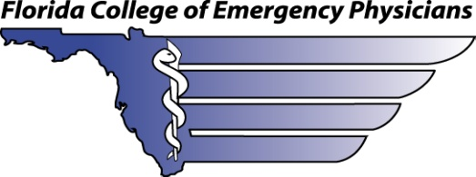
Officers | Board of Directors
Steven Kailes, MD, FACEP | Patrick Agdamag, MD, FACEP
President | Damian Caraballo, MD
 | Dagan Dalton, MD, FACEP
Jay Falk, MD, FACEP | Vidor Friedman, MD, FACEP, Ex Officio
President-Elect | Danyelle Redden,, MD
 | Robyn Hoelle, MD, FACEP
Joel Stern, MD, FACEP, FAAEM | Amy Kelley, MD, FACEP
Vice-President | René Mack, MD
 | Kristin McCabe-Kline, MD, FACEP
Joseph A. Tyndall, MD, FACEP | William McConnell, DO, FACEP
Secretary-Treasurer | Joe Nelson, DO, FACEP, Ex Officio
 | Sanjay Pattani, MD, FACEP
Ashley Booth-Norse, MD, FACEP | Joseph Adrian Tyndall, MD, FACEP
Immediate Past President | Jill Ward, MD
 | Kendall Webb, MD
Executive Director | Aaron Wohl, MD, FACEP
Beth Brunner, MBA, CAE

A CHAPTER OF THE AMERICAN COLLEGE OF EMERGENCY PHYSICIANS
3717 South Conway Road ● Orlando, FL 32812
(407) 281-7396 ● FAX (407) 281-4407
(800) 766-6335 ● www.fcep.org

EMRAF Scholarship
EMRAF Scholarship: $500
- Awarded to the most active EMRAF committee member
- Award Stipulations: must be used towards registration/travel expenses of any FCEP or ACEP conference/program or educational experience

- Minimum Criteria:
o Must attend FCEP’s Annual Emergency Medicine Days and/or Symposium by the Sea (at least one)
o Must attend at least 50% of FCEP’s scheduled committee meetings
o Takes an active role in a FCEP/EMRAF project or program

- Scholarship awarded recipient will be chosen by a committee made up of:
o the FCEP Executive Board,
o FCEP’s Executive Director,
o Professional Development & Membership Co-Chair/EMRAF Coordinator and
o FCEP/FEMF’s EMRAF Staff Liaison
- Decision must be made by July 15th of each calendar year.
- Scholarship will be awarded at the EMRAF Committee Meeting at FCEP’s Annual Symposium by the Sea.

